Solution of the Machine Design-II Problems

Problem #M5: Gear kinematics: The figure shows an epicyclic gear train. The number of teeth on each gear is as follows:

N2=20 N5=16

N4=30

The input is Gear 2 and its speed is 250 rpm clockwise (positive). Gear 6 is fixed. Determine the speed of the arm and the speed of Gear 4. The drawing is not to scale.

d₅ + d₆ = d₂ + d₄ and since all P are the same we get
N₅ + N₆ = N₂ + N₄ and N₆ = 34 teeth
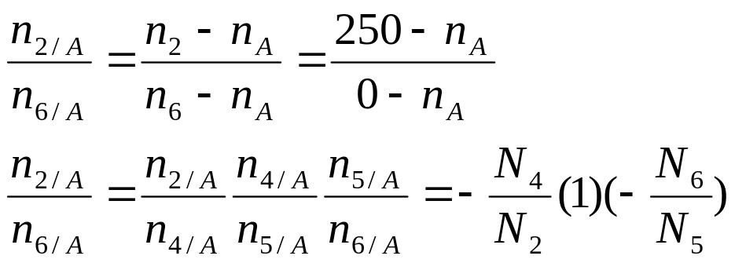

Substituting for the number of teeth on each gear

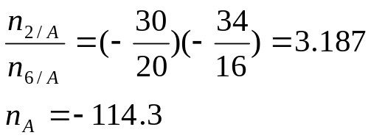

Also

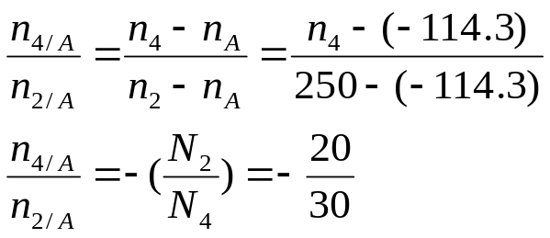
From above:
n₄=-357.1 rpm

Problem # M6 : A pair of spur gears with a pitch of 6 are in mesh. The pinion has 18 teeth and rotates at 1800 rpm transmitting 0.5 Hp. Both gears have 20-degree pressure angles. The number of teeth on the gear is 36. Determine the radial and tangential forces on the pinion.

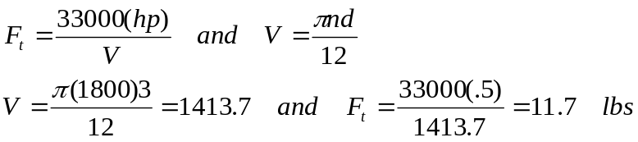

The radial stress is:

Problem # M7: A pair of helical gears transmit 15 KW power and the pinion is rotating at 1000 rpm. The helix angle is 0.50 radians and the normal pressure angle is 0.35 radians. The pitch diameter of the pinion is 70 mm and the pitch diameter of the gear is 210 mm. Determine the tangential, radial, and axial forces between the gear teeth. (Answers: 4092, 1702, 2236 Newtons)

The tangential load is determined from the power relationship. The relationship in SI units uses the driving torque:
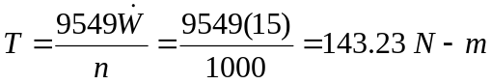
where the power is in Kw (Ref. Eq. 1.2 of Juvinall). The tangential load creating this torque is:
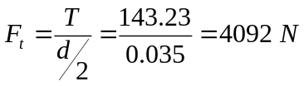
The radial and axial forces are:
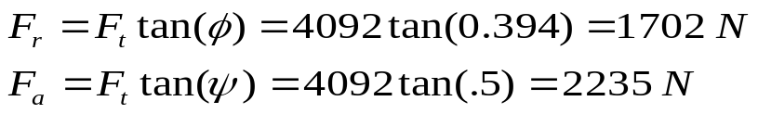
Note that:
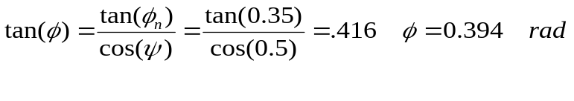
Problem #M8: A pair of straight-tooth bevel gears (as shown in the figure above) are in mesh transmitting 35 hp at 1000 rpm (pinion speed). The gear rotates at 400 rpm. The gear system has a pitch of 6 and a 20-degree pressure angle. The face width is 2 inches and the pinion has 36 teeth. Determine the tangential, radial, and axial forces acting on the pinion. Answers (839 lbs, 283 lbs, 113 lbs).
d
d_{avg}
b
γ
From the gear geometric information:
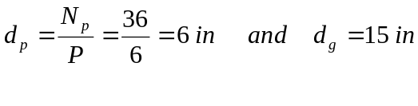
The pitch cone angle can be obtained from the ratio of pitch diameters (Ref. Eq 16-16 Juvinall).
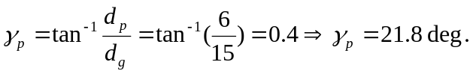
From geometry, the average diameter of the pinion is:
The pinion’s average pitch-line velocity is:
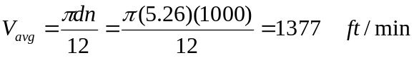
Now we can find the tangential force :
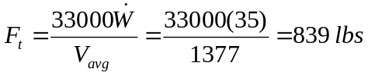
The axial and radial forces are:
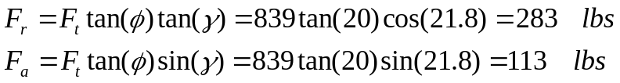

Problem #M9: A worm gear reducer is driven by a 1200 rpm motor. The worm has 3 threads and the gear has 45 teeth. The circular pitch of the gear is p=0.5”, the center distance is 4.5 inches, the normal pressure angle is 20 degrees, and face-width of the gear is b=1 inch. Use a coefficient of sliding friction of 0.029. Determine:
- Gear and worm diameters, and worm Lead. (7.16, 1.84, 1.5 in)
- The worm gear efficiency (88.6%)
- Is the unit self-locking – show work? (No)

The gear pitch diameter can be found from the number of teeth and its circular pitch:
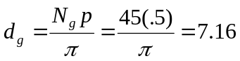
The pitch diameter of the worm can be obtained from the center distance and the pitch diameter of the gear:
The lead is the number of threads in the worm times the worm’s axial pitch which is the same as the gear’s circular pitch:
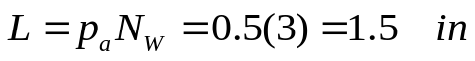
The gear efficiency can be obtained knowing the sliding friction as well as the normal pressure angle and the lead angle of the worm. The lead angle of the worm is:
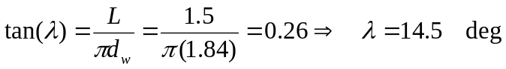
The efficiency:
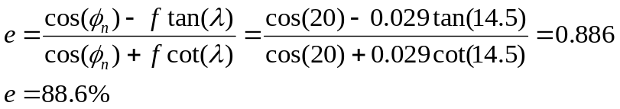
The gearset is reversible because the friction coefficient f=0.029 is less than that required for locking which is:

Problem M #10: A 10”-wide flat belt is used with a driving pulley of diameter 16” and a driven pulley of rim diameter 36” in an open configuration. The center distance between the two pulleys is 15 feet. The friction coefficient between the belt and the pulley is 0.80. The belt speed is required to be 3600 ft/min. The belts are initially tensioned to 544 lbs. Determine the following. (answers are in parentheses)

Belt engagement angle on the smaller pulley (3.03 radians).
Force in belt in the tight side just before slippage. (1000 lbs).
Maximum transmitted Hp. (99.4 hp)

The engagement angle is:
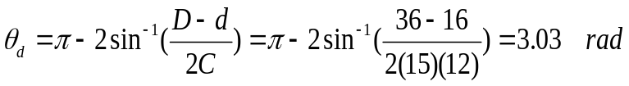
At the verge of slippage:
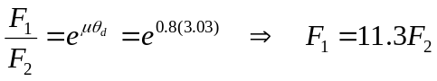
Also:

The transmitted Hp is:
